Date:
GP:

Dear Dr,

This man underwent No-Scalpel Vasectomy today after counseling on failure rate, potential complications and need for post-operative semen analysis at 16 weeks.

He has been provided with instructions on semen analysis at 16 weeks and given advice on postoperative care. Further information can be obtained from: www.myvasectomy.ie

He has been given a 3 day supply of co-amoxyclav/clarithromycin and advised to take paracetamol or solpadeine for pain relief.

Yours sincerely,
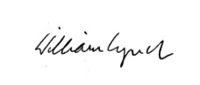
____________________________
Dr William Lynch MRCGP MICGP
IMC 011267

