Date:
Mr.

Dear

I enclose a copy of your test results which confirm that your procedure was a success.

Best wishes for the future.

Yours sincerely,
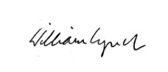
____________________________
Dr William Lynch MRCGP MICGP
IMC 011267

Encl.

